**Hedge Fund**

A hedge fund is a private investment fund which collects and combines money from different investors and invests it in different areas like stocks, real estate or bonds at a very high risk for high returns.

It involves deep analysis, trading strategies and risk management to get the best possible returns.

**AI Hedge fund:**

The project works on a mechanism that has been driven by AI agents. AI agents are systems that interact with humans, or other computer systems for processing information and taking actions to achieve predetermined goals.

There are mainly 5 types of AI agents functioning in the project. The agents are:

1. Simple Reflex Agents – React to specific conditions using predefined rules (e.g., Technicals, Risk manager).

2. Model-Based Agents – Maintain an internal model of the world to make decisions (e.g., Fundamentals, Valuation).

3. Goal-Based Agents – Select actions based on long-term objectives (e.g., Portfolio Manager, Stanley Druckenmiller).

4. Utility-Based Agents – Optimize outcomes based on a mathematical utility function (e.g., Warren Buffet, Bill Ackman, Charlie Munger).

5. Learning Agents – Continuously improve through experience and data (e.g., Cathie Wood, Sentiment, Ben Graham).

**1️. Simple Reflex Agents (Rule-Based, React to Market Conditions)**

These agents follow predefined rules and react to market signals without deep learning.

* Technicals → Uses moving averages (Ref: ARIMA), RSI, MACD to make trading decisions.
* Risk Manager → Enforces stop-loss, position sizing, and portfolio diversification rules.

**2️. Model-Based Agents (Internal Model of Market, Context-Aware)**

These agents maintain an understanding of market conditions and adjust based on trends.

* Fundamentals → Evaluates company financials (P/E ratio, revenue, earnings).
* Valuation → Determines intrinsic stock values using DCF, multiples, and comparative analysis.

**3️. Goal-Based Agents (Optimizing Investment Strategies for a Target)**

These agents select actions based on maximizing long-term returns.

* Portfolio Manager → Optimizes asset allocation to balance risk and return.
* Stanley Druckenmiller → Focuses on macroeconomic trends and capital flows to select assets.

**4️. Utility-Based Agents (Decision-Making with Risk-Reward Calculations)**

These agents quantify probabilities and expected returns for every trade.

* Warren Buffett → Picks high-value, long-term investments based on business fundamentals.
* Charlie Munger → Looks for companies with durable competitive advantages ("moats").
* Bill Ackman → Activist investing approach, improving corporate performance for high returns.

**5️. Learning Agents (AI-Driven, Adaptive Strategies)**

These agents evolve and improve their decision-making over time.

* Cathie Wood → Identifies disruptive innovation trends using AI-driven research.
* Sentiment → Uses NLP to analyze news, earnings calls, and social media for market mood. (Ref: Sentiment Analysis, VADER)
* Ben Graham → Uses historical data to refine deep-value investing strategies.

**Summary Table**

| **AI Agent** | **Type of AI Agent** | **Primary Function** |
| --- | --- | --- |
| **Technicals** | **Simple Reflex Agent** | **Uses indicators like MACD, RSI** |
| **Risk Manager** | **Simple Reflex Agent** | **Enforces risk limits, stop-loss** |
| **Fundamentals** | **Model-Based Agent** | **Evaluates financial health** |
| **Valuation** | **Model-Based Agent** | **Estimates stock intrinsic value** |
| **Portfolio Manager** | **Goal-Based Agent** | **Allocates assets for optimal returns** |
| **Stanley Druckenmiller** | **Goal-Based Agent** | **Macro trends, liquidity shifts** |
| **Warren Buffett** | **Utility-Based Agent** | **Long-term fundamental investing** |
| **Charlie Munger** | **Utility-Based Agent** | **Competitive advantage investing** |
| **Bill Ackman** | **Utility-Based Agent** | **Activist investing strategies** |
| **Cathie Wood** | **Learning Agent** | **Identifies disruptive stocks** |
| **Sentiment** | **Learning Agent** | **NLP-based market sentiment analysis** |
| **Ben Graham** | **Learning Agent** | **Data-driven value investing** |

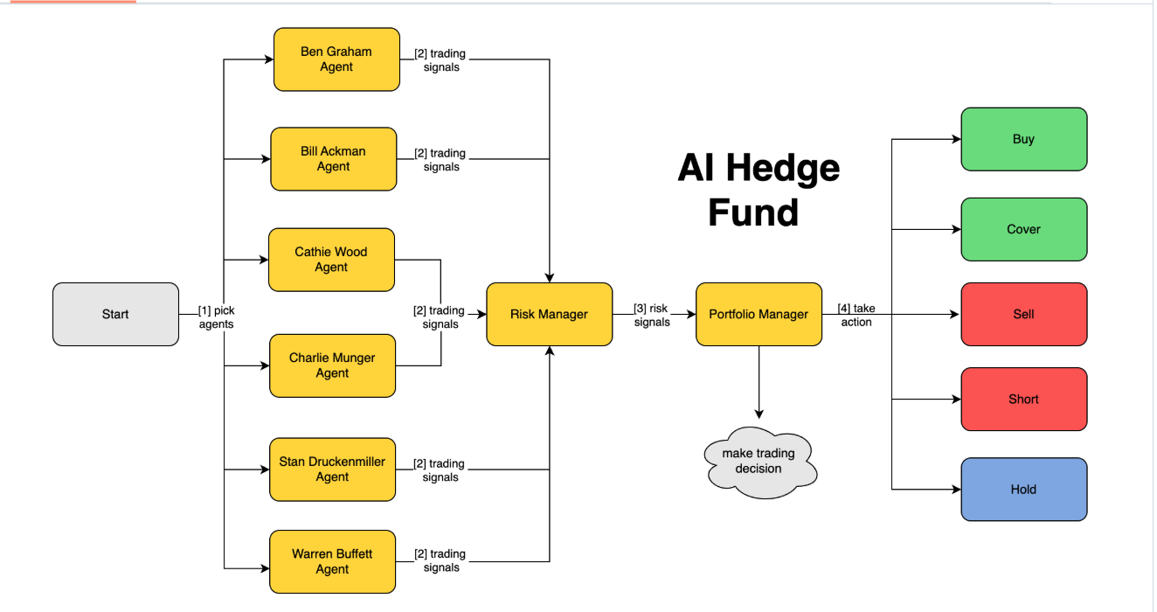**AI Hedge fund operational chart**

**The operation of AI hedge fund can be categorized into 4 phases:**

1. **Pick agents.**

**Ben Graham Agent** → Focuses on deep value investing.

**Bill Ackman Agent** → Implements activist investing strategies.

**Cathie Wood Agent** → Identifies high-growth and disruptive technology stocks.

**Charlie Munger Agent** → Invests in companies with strong competitive advantages.

**Stanley Druckenmiller Agent** → Uses macroeconomic trends to select investments.

**Warren Buffett Agent** → Focuses on long-term, high-quality business investments.

1. **Trading signals.**

Each AI agent analyzes market data based on its unique strategy and produces trading signals.

These trading signals are sent to the Risk Manager for evaluation.

**Trading signals might include:**

* **Buy recommendation (e.g., undervalued stock).**
* **Sell recommendation (e.g., overpriced stock).**
* **Short recommendation (e.g., expected stock decline).**
* **Hold recommendation (e.g., maintain position).**

1. **Risk Signals**

* The Risk Manager collects and processes the trading signals from all AI agents.
* It applies risk management rules to assess portfolio exposure, volatility, and position sizing.
* If a trade exceeds risk limits (e.g., too much exposure to a single sector or stock), the Risk Manager modifies or rejects it.
* The Risk Manager then **sends risk-adjusted signals** to the **Portfolio Manager**.

1. **Actions. (Decision Making)**

* The Portfolio Manager consolidates all input from the Risk Manager.
* It decides the final actions to take based on a combination of:
* Trading signals from AI agents.
* Risk constraints from the Risk Manager.
* Market conditions and historical performance.

The Portfolio Manager executes one of the following actions:

Buy → Purchase stocks expected to rise.

Sell → Sell holdings to lock in profits or cut losses.

Short → Borrow stocks to sell at a high price and buy them back at a lower price.

Cover → Close out a short position by buying back the stock.

Hold → Maintain the current position with no new trades.

The final action is executed in the market automatically by an AI agent or manually by any authorized person.